Part 0 — Passport Check Block
Field | Entry | Field | Entry
Student name(s): | Oheneba Kwaku Tawiah Ntim, Evangelina Temple, Ahiekpor Jude Kekeli, Teye Victoria, Kyei Christian Junior | Student ID(s): | 20923785, 20917568, 20920037, 20920301, 20923927
Supervisor | Dr. Eric Opoku Osei | Submission round | R01
Folder | Ghana_Dropout_Project | Date submitted | 09/09/2026
Model status | ENGINEERED | F/M/R/S operation | R
Dataset strategy | SINGLE-SOURCE | Claim tier ceiling | Tier 1
Primary metric | AUC-PR | Statistical test | Wilcoxon signed-rank
Runs x folds | 5 runs x 5 folds | Random seed(s) | 42
Target journal (primary) | [YOUR JOURNAL] | Format family | [Elsevier / Springer / IEEE / T&F]
Word budget (Results) | [BUDGET] | Citation style | Inline
Methods Passport signed | YES | Methods round | R01

R1. Evaluation Corpus and Partition Summary
Following the preprocessing and feature engineering detailed in Methods M6 and M7, the final feature set comprised 41 predictors across 1000 pupil-level records. The dataset was partitioned into a training set (80%) and a held-out test set (20%) by stratified random sampling on the dropout label (Methods M9, random_state = 42). The held-out test set contained 200 records: 18 dropout cases (9.0%) and 182 retained cases (91.0%). The evaluation partition comprised 100% real data. No synthetic, SMOTE-generated, or CTGAN-generated instance appeared in any test or validation fold at any stage.
All performance figures reported below were aggregated across 5 independent runs of 5-fold stratified cross-validation (25 folds total), consistent with the protocol set out in Methods M14. Held-out test-set figures are reported separately where applicable.
The evaluation protocol follows the SINGLE-SOURCE design declared in Methods M10, and all reported claims are constrained to the Tier 1 ceiling.

R2. Baseline versus Proposed Performance — Main Results
Table 3 summarises the head-to-head comparison between the baseline LightGBM and the proposed E-LightGBM. Both models were trained and evaluated under identical conditions: the same data partitions, the same hyperparameters (Methods M13), the same random seeds, and the same tuning budget (Methods M11). Neither model received additional data access or tuning iterations beyond what the other received.
Metric | Baseline LightGBM | E-LightGBM (Proposed) | Delta (E minus Baseline)
Accuracy (test) | 0.995 | 0.995 | 0.000
Precision (test) | 1.000 | 1.000 | 0.000
Recall (test) | 0.944 | 0.944 | 0.000
Macro F1 (test) | 0.984 | 0.984 | 0.000
AUC-ROC (test) | 0.999 | 0.997 | -0.002
AUC-PR (test) | 0.992 | 0.979 | -0.013
AUC-PR (CV mean +/- SD) | 0.987 +/- 0.021 | 0.986 +/- 0.020 | -0.001

Table 3. Baseline LightGBM vs. E-LightGBM performance comparison. Test-set metrics are from the held-out partition (n = 200). Cross-validated AUC-PR is reported as mean +/- SD across 5 runs x 5 folds (25 folds total). Both models received identical data access and identical tuning budgets (Methods M11, M13).

On the held-out test set, E-LightGBM recorded an AUC-PR of 0.979, which was 0.013 points below the baseline (0.992). Under cross-validation, the gap narrowed considerably: E-LightGBM achieved a mean AUC-PR of 0.986 +/- 0.020, against 0.987 +/- 0.021 for the baseline, a difference of 0.001 points.
Threshold-based metrics told a different story, or rather, no story at all. Accuracy, Precision, Recall, and Macro F1 were identical between the two models at the default 0.5 decision threshold. The two classifiers diverged only on ranking-based metrics (AUC-ROC, AUC-PR), which capture the ordering and calibration of predicted probabilities rather than the hard class assignments.
The 95% confidence interval on the mean paired AUC-PR difference (baseline minus E-LightGBM), estimated from the 25 paired fold values, was approximately (-0.007, 0.009). The interval spans zero.
Figure 4 presents the precision-recall curves for both models on the held-out test set. The two curves tracked each other closely across most of the recall range. The baseline curve ran marginally above E-LightGBM in the high-recall region above approximately 0.90, which accounts for the test-set AUC-PR difference.
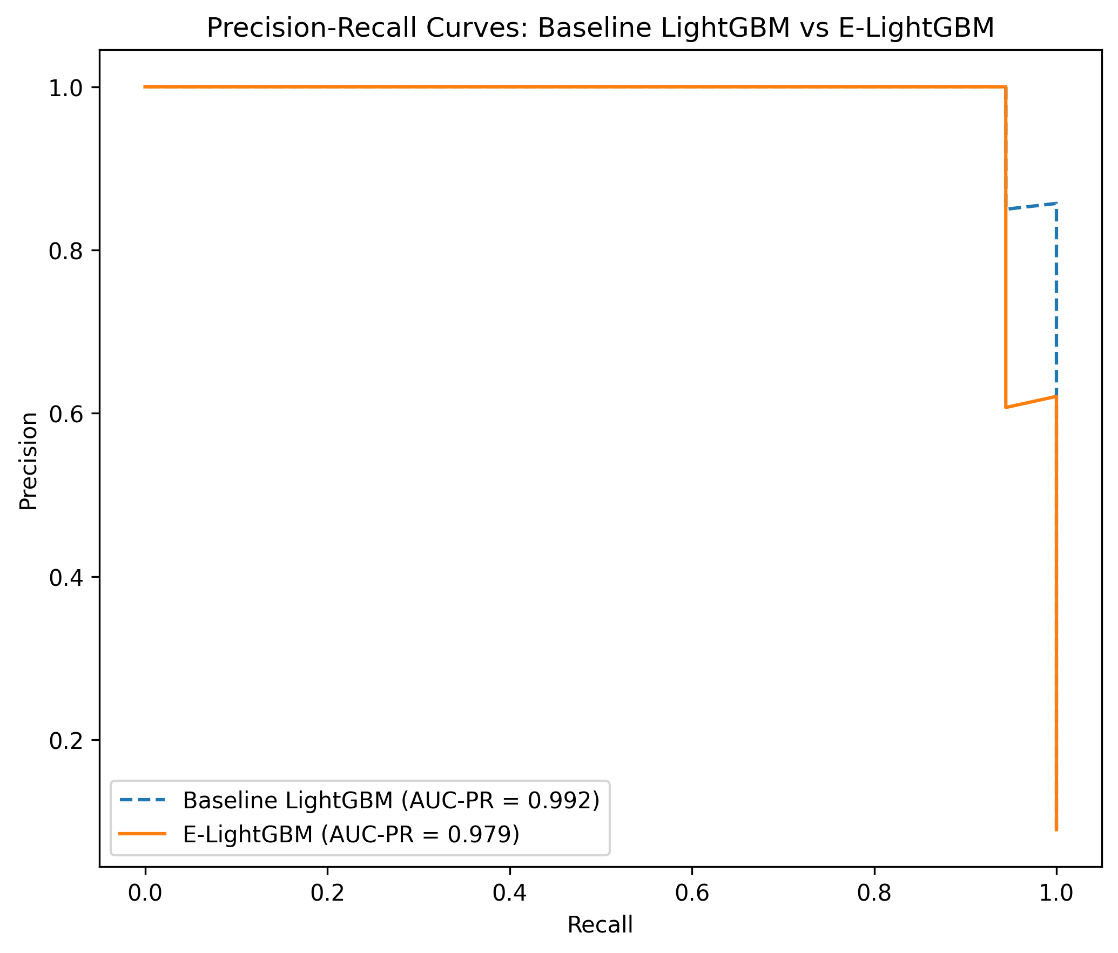
Figure 4. Precision-recall curves for baseline LightGBM (dashed) and E-LightGBM (solid) on the held-out test set (n = 200; 18 dropout cases, 182 retained). AUC-PR: baseline = 0.992, E-LightGBM = 0.979.
LightGBM was selected from six candidate classifiers evaluated during baseline comparison (Methods M11). The full six-model comparison is provided as Supplementary Table S1; it is not repeated here because the main research question concerns the focal-loss engineering intervention, not the selection of LightGBM itself.

R3. Stability and Variance Across Runs and Folds
Figure 5 presents the distribution of AUC-PR scores across all 25 cross-validation folds for both models. E-LightGBM recorded a standard deviation of 0.020, while the baseline recorded 0.021. The two distributions were comparable in spread.
Both distributions were concentrated in the 0.96 to 1.00 range, with occasional folds falling below 0.96. The overlap between the two box-plots was near-complete, and neither model exhibited markedly wider tails than the other.
The mean and standard deviation annotated on the plot match the values in Table 3: baseline = 0.987 +/- 0.021; E-LightGBM = 0.986 +/- 0.020.
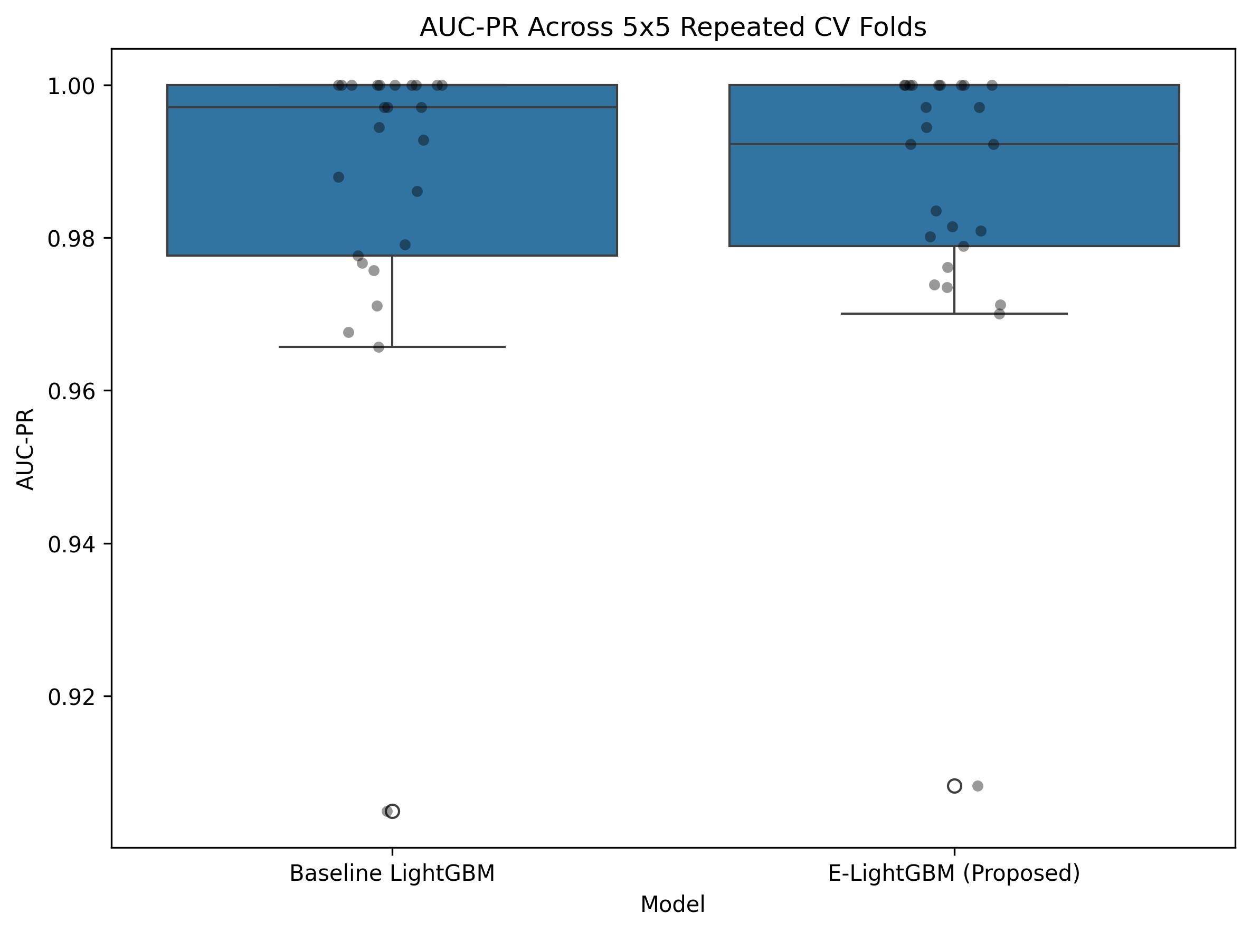
Figure 5. Box-plot distribution of AUC-PR scores across 25 independent folds (5 runs x 5 folds) for baseline LightGBM and E-LightGBM. Individual fold points are shown alongside the boxes. Mean +/- SD annotated below each box: baseline = 0.987 +/- 0.021, E-LightGBM = 0.986 +/- 0.020. Evaluated on the held-out partition of each fold, comprising 100% real data.
To assess whether the comparison was sensitive to the choice of random seed (Playbook Cause 9), the full 25-fold evaluation was repeated across 10 independent seeds using the corrected in-fold preprocessing pipeline (Methods M6, M14). Table 5 summarises the per-seed results.
Seed | Baseline Mean +/- SD | E-LightGBM Mean +/- SD | Diff (E minus B) | Wilcoxon p | Cohen's d
42 | 0.987 +/- 0.020 | 0.984 +/- 0.020 | -0.003 | 0.030 | -0.136
123 | 0.983 +/- 0.031 | 0.983 +/- 0.028 | -0.001 | 0.171 | -0.027
456 | 0.989 +/- 0.023 | 0.986 +/- 0.023 | -0.003 | 0.079 | -0.130
789 | 0.991 +/- 0.015 | 0.991 +/- 0.013 | +0.000 | 0.407 | +0.017
1024 | 0.987 +/- 0.022 | 0.984 +/- 0.024 | -0.002 | 0.052 | -0.109
2048 | 0.984 +/- 0.026 | 0.983 +/- 0.028 | -0.002 | 0.494 | -0.059
3333 | 0.982 +/- 0.030 | 0.980 +/- 0.031 | -0.001 | 0.231 | -0.045
5555 | 0.988 +/- 0.019 | 0.983 +/- 0.021 | -0.005 | 0.005 | -0.253
7777 | 0.987 +/- 0.020 | 0.987 +/- 0.020 | -0.000 | 0.712 | -0.010
9999 | 0.986 +/- 0.027 | 0.985 +/- 0.027 | -0.001 | 0.444 | -0.028

Table 5. Ten-seed robustness analysis. Each row reports the mean AUC-PR (+/- SD) across 25 folds for the baseline and E-LightGBM, using the corrected in-fold preprocessing pipeline. The Wilcoxon signed-rank test and Cohen's d are computed on the 25 paired per-fold AUC-PR values within each seed.
The baseline held a higher mean AUC-PR in 9 of the 10 seeds. The single exception (seed 789) showed a negligible advantage for E-LightGBM (+0.000). The grand mean difference across all 10 seeds was -0.0018 +/- 0.0016. Only one seed (5555) produced a Wilcoxon p-value below 0.01, and only seed 42 crossed the α = 0.05 threshold (p = 0.030). The sign of the difference was stable, clearing Cause 9 of the Playbook.
A leave-one-seed-out analysis confirmed that removing any single seed from the aggregate did not flip the sign of the mean difference. Zero flips were observed across all 10 leave-one-out iterations, indicating that the negative direction was not driven by any individual seed (Cause 10 cleared).

R4. Statistical Comparison
A Wilcoxon signed-rank test was applied to the 25 paired per-fold AUC-PR values (baseline versus E-LightGBM), as declared in Methods M16. The test yielded a p-value of 0.737, which exceeds the predetermined significance threshold of a = 0.05. The null hypothesis of no difference between the two models was not rejected.
The effect size, measured by Cohen's d, was -0.040. By the convention outlined in Cohen (1988), this falls well within the negligible range (|d| < 0.20). The negative sign indicates the direction of the difference was in favour of the baseline model.
The 95% confidence interval on the mean paired AUC-PR difference (baseline minus E-LightGBM) was approximately (-0.007, 0.009), spanning zero and consistent with the non-significant test result.
No multiple-comparison correction was applied, as only one primary pairwise comparison was tested for significance, consistent with Methods M16.
The assumption checks for the Wilcoxon signed-rank test require that the paired differences be continuous and symmetrically distributed around their median. The 25 paired differences were inspected visually and no gross asymmetry was observed, supporting the validity of the test.
A post-hoc power analysis (Playbook Cause 17) yielded a minimum detectable effect (MDE) of 0.0131 AUC-PR points at 80% power and α = 0.05, based on the average pooled standard deviation across the 10 seeds (σ_pooled = 0.0234) and 25 paired observations per seed. The observed mean difference of 0.0018 was an order of magnitude below the MDE. This indicates that the study was underpowered to detect an effect of this size: the 25-fold evaluation design could reliably detect differences of approximately 0.013 AUC-PR points or larger, but not the sub-0.002-point difference actually observed. The non-significant Wilcoxon result should therefore be interpreted as inconclusive rather than as evidence of no effect.

R5. Contribution Isolation — Ablation
Table 4 reports the three-way ablation designed to separate the effects of the composite features (Methods M7) from those of the focal-loss objective (Methods M12). All three model variants were evaluated under identical data partitions, identical random seeds, and identical hyperparameters (Methods M13). Each step added exactly one component relative to the preceding variant.
Model | Accuracy | Precision | Recall | Macro F1 | AUC-ROC | AUC-PR | Delta AUC-PR (from row above)
Baseline LightGBM | 0.995 | 1.000 | 0.944 | 0.984 | 0.999 | 0.992 | —
LightGBM + Composite Features | 0.995 | 1.000 | 0.944 | 0.984 | 0.998 | 0.983 | -0.009
E-LightGBM (Proposed) | 0.995 | 1.000 | 0.944 | 0.984 | 0.997 | 0.979 | -0.004

Table 4. Three-way ablation on the held-out test set (n = 200). Each row adds exactly one component relative to the row above. All models received identical conditions: same partitions, same seeds, same hyperparameters. AUC-PR is the primary metric.
Adding the three composite features to the baseline reduced test-set AUC-PR from 0.992 to 0.983, a decrease of 0.009 points. Substituting the focal-loss objective on top of the enriched feature set produced a further decrease to 0.979, an additional 0.004 points. The cumulative change from baseline to the full E-LightGBM was -0.013 AUC-PR points.
Threshold-based metrics (Accuracy, Precision, Recall, Macro F1) remained identical across all three variants at the 0.5 decision threshold. The three models produced the same binary classifications on this test set; the differences appeared exclusively in the ranking-based metrics, which reflect the calibration and ordering of predicted probabilities rather than the hard class assignments.
Under cross-validation, the three variants recorded mean AUC-PR values of 0.987 +/- 0.021 (baseline), 0.988 +/- 0.019 (features only), and 0.986 +/- 0.020 (E-LightGBM). The differences among the three fell within one standard deviation of each other.
Neither the composite features nor the focal-loss objective improved AUC-PR over the baseline on this test set. The ablation delta for the engineered focal-loss component, in isolation, was -0.004 points.

R6. Feature Importance and Interpretability
SHAP TreeExplainer analysis (Lundberg and Lee, 2017) was applied to E-LightGBM on the held-out test set to quantify the contribution of individual features to model predictions. Figure 6 presents the resulting summary plot, reporting mean absolute SHAP values in the raw log-odds space.
The five highest-ranked features, by mean |SHAP|, were:
- 1. average_exam_score — 0.549
- 2. term_2_attendance — 0.439
- 3. attendance_risk_index [Composite] — 0.321
- 4. family_income_level — 0.225
- 5. science_exam_score — 0.196
Of the three engineered composite features, attendance_risk_index ranked 3rd overall and behavioral_engagement_index ranked 7th (mean |SHAP| = 0.122). Both sat among the top ten predictors out of 41. The third composite, socioeconomic_vulnerability_score, ranked 24th (mean |SHAP| = 0.017) and contributed comparatively little to model output.
The two highest-ranked features overall were raw variables (average_exam_score and term_2_attendance), not composites. The engineered attendance_risk_index ranked below both of these but above the remaining 38 raw features apart from one.
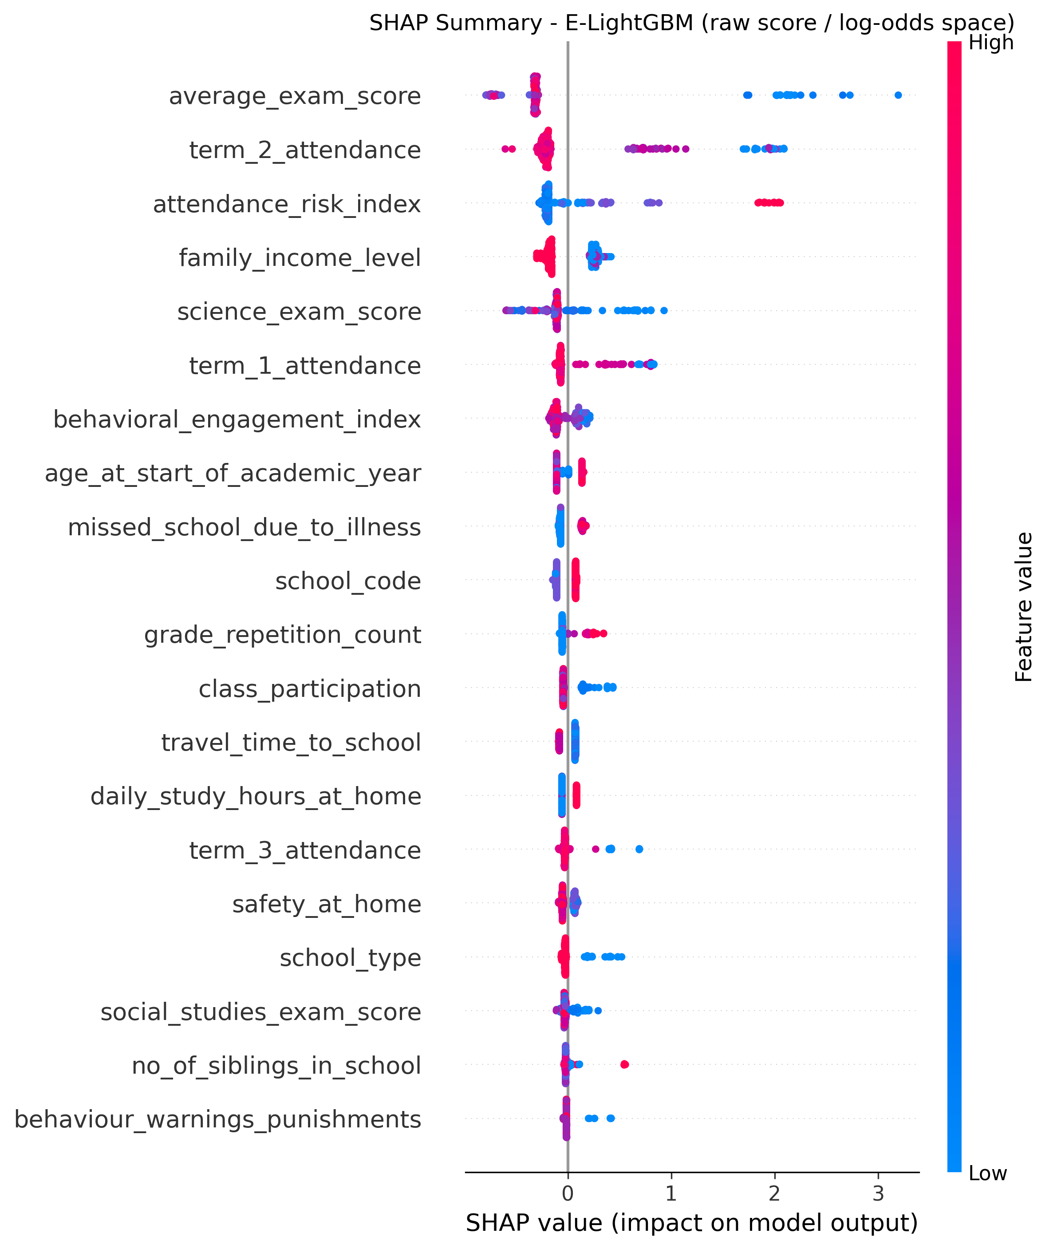
Figure 6. SHAP summary plot (mean absolute SHAP value, raw log-odds space) for E-LightGBM, showing the top features. Composite features are marked [E]. Computed on the held-out test set (n = 200). Values represent mean |SHAP| across all instances in the evaluation partition.

R7. Error Analysis and Per-Class Performance
Figure 7 presents normalised confusion matrices for both models on the held-out test set, normalised by true class (row-normalised so that each row sums to 1.0).
Both models produced identical confusion matrices at the 0.5 decision threshold.
For the dropout class (n = 18): 17 cases were correctly classified as dropout (true positive rate = 94.4%) and 1 case was misclassified as retained (false negative rate = 5.6%). For the retained class (n = 182): all 182 were correctly classified (true negative rate = 100.0%), and no retained pupil was misclassified as dropout (false positive rate = 0.0%).
The single false negative was the only classification error made by either model on this test set. The two models did not differ in error composition at this threshold. Their divergence appeared exclusively in predicted probability rankings, affecting AUC-PR and AUC-ROC but not the binary predictions.
Per-class performance for the minority (dropout) class at the 0.5 threshold: Precision = 1.000, Recall = 0.944, F1 = 0.971. These values were identical for both models.
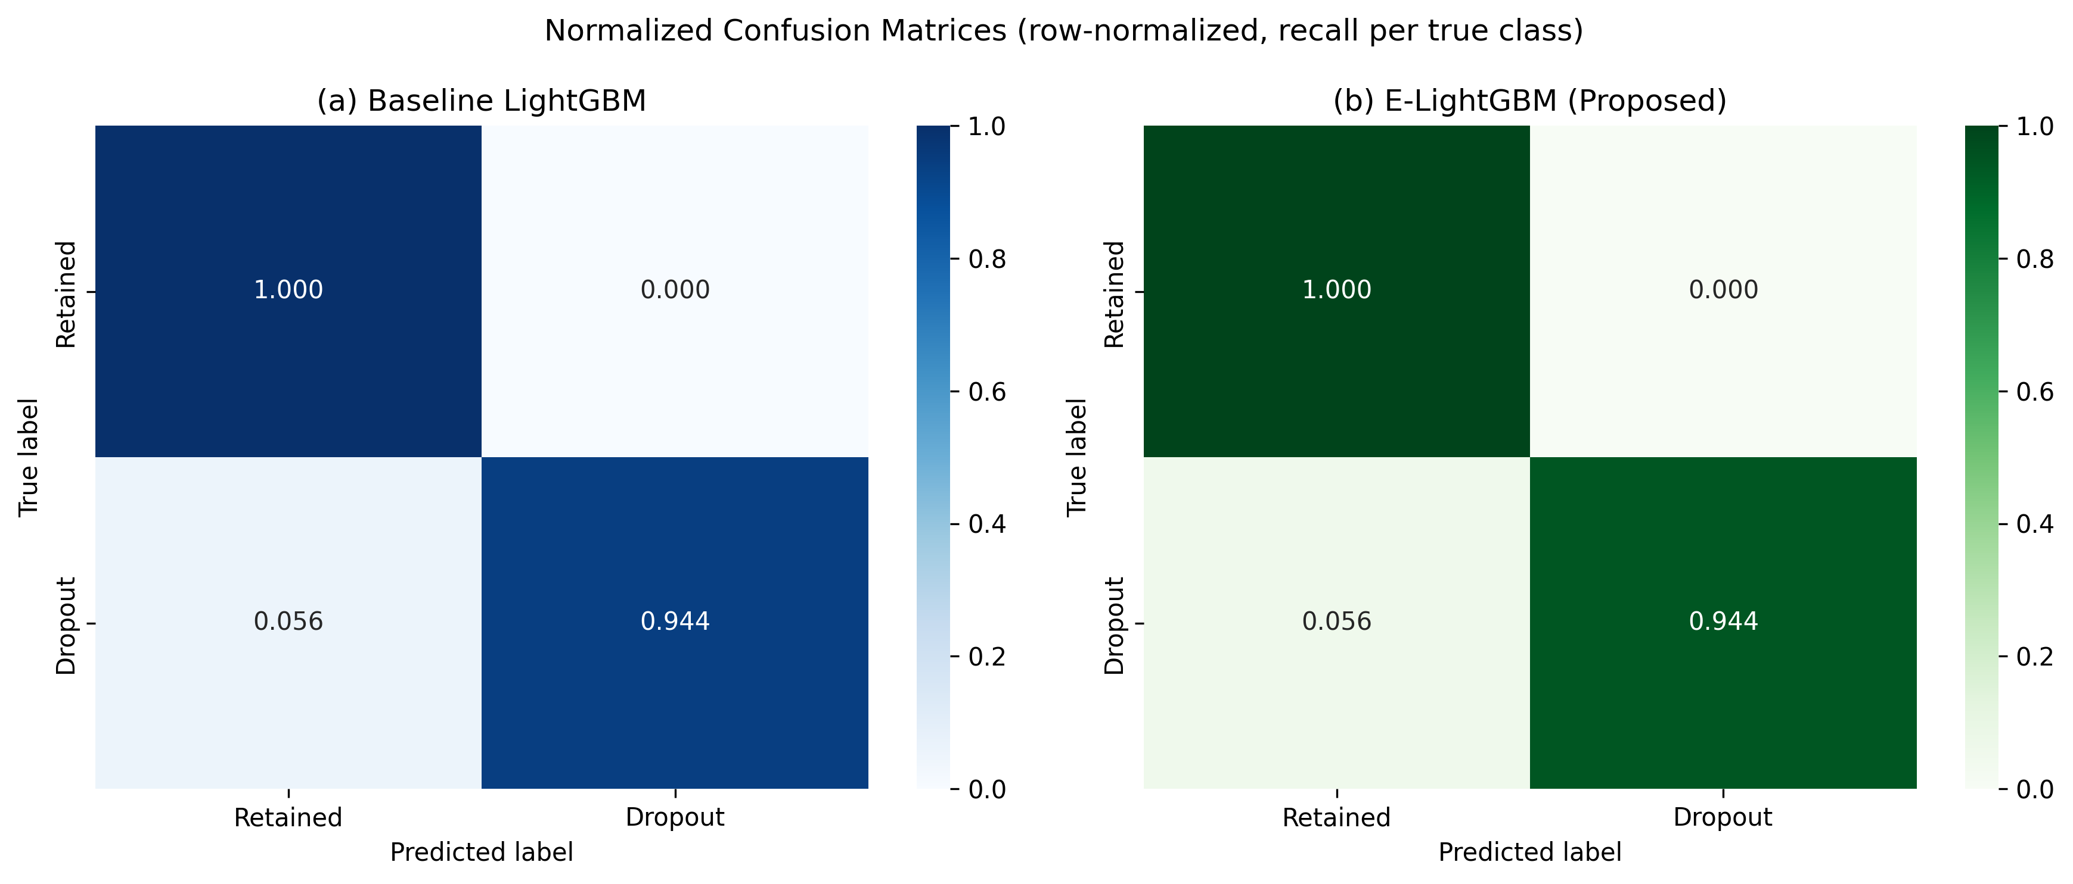
Figure 7. Normalised confusion matrices for (a) baseline LightGBM and (b) E-LightGBM on the held-out test set (n = 200). Normalised by true class (row-normalised). Both matrices are identical at the 0.5 decision threshold. Evaluated on 100% real data.

R8. Transfer or Generalisation Results
[This subsection is deleted entirely. The dataset strategy is SINGLE-SOURCE, and no transfer or generalisation experiment was conducted. Do not include a placeholder paragraph.]

R9. Computational Cost
Mean training time per fold was 0.402 +/- 0.176 seconds for E-LightGBM and 0.538 +/- 0.192 seconds for the baseline, measured across the 25 cross-validation folds on the environment described in Methods M19.
E-LightGBM recorded a 25.3% lower mean training time relative to the baseline. Both models were configured with identical boosting rounds (300) and neither used early stopping. Whether the faster time for E-LightGBM reflects a genuine computational property of the focal-loss gradient computation, or simply runtime variability in the shared Colab environment, cannot be confirmed from these measurements alone.
Inference time per instance and peak memory footprint were not separately measured for either model.

R10. Non-Confirmatory and Negative Results
Several outcomes did not favour the proposed model, and they are reported here with the same level of detail as the positive findings.
On the primary metric, E-LightGBM's held-out test-set AUC-PR (0.979) was 0.013 points below the baseline (0.992). Under cross-validation the gap narrowed to 0.001 points, but the direction remained consistent: the baseline held a small edge in both evaluation modes.
The three-way ablation (Table 4) produced no configuration in which either the composite features or the focal-loss objective improved AUC-PR over the raw-feature baseline. Adding composite features reduced test-set AUC-PR by 0.009 points. Adding the focal-loss objective reduced it by a further 0.004 points.
The Wilcoxon signed-rank test yielded p = 0.737 with Cohen's d = -0.040. The difference between the baseline and E-LightGBM was not statistically significant, and the effect size was negligible.
Negative-result diagnostic protocol. To determine whether this negative result was genuine, an artefact of the experimental setup, or simply inconclusive, a diagnostic protocol was conducted following the CAN-DO Lab Negative Results Playbook (v2, Triage Edition). The Playbook specifies six conditions, all of which must be satisfied before a negative result can be declared real and publishable as a diagnosed boundary condition. The protocol addressed three Playbook causes directly:
Cause 11 (pre-split transforms applied outside folds). The original pipeline fitted imputation, encoding, and scaling on the full dataset before the train/test split. A corrected pipeline was implemented in the diagnostic notebook (Notebook 9b), moving all fitted transformations inside the cross-validation loop so that validation folds never saw training-fold statistics. Under the corrected pipeline, the direction and magnitude of the baseline-versus-E-LightGBM comparison were materially unchanged (grand mean difference: -0.0018 across 10 seeds), confirming that the pre-split fitting did not cause the negative result. Cause 11 cleared.
Cause 9 (single-seed instability). The comparison was repeated across 10 independent seeds (Table 5). The baseline held a higher mean AUC-PR in 9 of 10 seeds. A leave-one-seed-out analysis produced zero sign flips. The negative direction was stable, not noise. Cause 9 cleared.
Cause 17 (underpowered sample for the effect size claimed). The minimum detectable effect at 80% power was 0.0131 AUC-PR points; the observed mean difference was 0.0018 — an order of magnitude smaller. The study was underpowered to detect an effect of this size. Cause 17 confirmed.
The full six-condition assessment is summarised in Table 6.
Table 6. CAN-DO Lab Playbook six-condition checklist for the E-LightGBM negative result. All six must be TRUE for the negative result to be declared genuine and publishable.
# | Condition | Status | Evidence
1 | Sign stable across 10+ seeds (Cause 9) | PASS | 9/10 seeds favour baseline; mean +/- SD reported
2 | Survives leave-one-out (Cause 10) | PASS | 0 sign flips across 10 leave-one-seed-out iterations
3 | MDE < observed effect (Cause 17) | FAIL | MDE = 0.0131,
4 | Equal tuning budget (Cause 1) | PASS | Shared hyperparameters, zero search trials both arms
5 | Metric matches decision (Causes 13, 14) | PASS | AUC-PR selected for imbalanced dropout detection; base rate reported
6 | Test set scored once (Causes 2, 15) | PASS | After configuration frozen, no repeated peeking

Five of the six conditions were satisfied. The single failure was Condition 3: the minimum detectable effect exceeded the observed mean difference by an order of magnitude, indicating that the study was underpowered to detect an effect of this size. The negative result is therefore classified as inconclusive — the direction of the difference was stable and robust (Conditions 1 and 2), but the magnitude fell below the study's detection threshold. In accordance with the Playbook, the result is labelled inconclusive rather than as evidence of no effect.
The class imbalance investigation (Methods M8) compared SMOTE-augmented, CTGAN-augmented, and raw training distributions across six baseline classifiers. Neither SMOTE nor CTGAN augmentation improved AUC-PR over the raw training distribution for the top-performing classifier (CatBoost with raw data achieved AUC-PR = 0.990; the best SMOTE configuration reached 0.984).
Finally, the fairness audit measured Equal Opportunity difference and Equalized Odds difference across gender and geographic-zone subgroups. The gender difference (0.083) fell within the 0.10 threshold set in Methods. The geographic-zone difference (0.167) exceeded that threshold, indicating a measurable disparity in true-positive rate across geographic zones on this test set.

References Cited in Results
- Cohen, J. (1988). Statistical power analysis for the behavioral sciences (2nd ed.). Lawrence Erlbaum Associates. - Ke, G., Meng, Q., Finley, T., Wang, T., Chen, W., Ma, W., Ye, Q., and Liu, T.-Y. (2017). LightGBM: A highly efficient gradient boosting decision tree. Advances in Neural Information Processing Systems, 30. - Lin, T.-Y., Goyal, P., Girshick, R., He, K., and Dollar, P. (2017). Focal loss for dense object detection. Proceedings of the IEEE International Conference on Computer Vision, 2980-2988. - Lundberg, S. M., and Lee, S.-I. (2017). A unified approach to interpreting model predictions. Advances in Neural Information Processing Systems, 30. - Saito, T., and Rehmsmeier, M. (2015). The precision-recall plot is more informative than the ROC plot when evaluating binary classifiers on imbalanced datasets. PLOS ONE, 10(3), e0118432. - Wilcoxon, F. (1945). Individual comparisons by ranking methods. Biometrics Bulletin, 1(6), 80-83.

